## Speaker Bios National Integrated Heat Health Information System (NIHHIS) Northeast Decision Calendar Workshop

## **18 October 2018**

*830AM – 4PM*

[Massachusetts Division of Fisheries and Wildlife (MassWildlife)](https://www.mass.gov/locations/masswildlife-fhq)

1 Rabbit Hill Road, Westborough, MA 01581

### Workshop Leaders

#### Hunter Jones

Hunter Jones is a Climate and Health Projects Manager within the National Oceanic and Atmospheric Administration (NOAA) Climate Program Office (CPO) serving as a UCAR CPAESS Affiliate. He is currently leading several local pilots of the National Integrated Heat Health Information System (NIHHIS) along the US Mexico border, and in the Northeast, to improve climate and health information for enhanced heat-health resilience. He is a founding member of the Global Heat Health Information Network (GHHIN), serves on its steering committee, and is working to plan the first GHHIN Global Forum in Southeast Asia.

#### Ellen Mecray

Ellen Mecray is the NOAA Regional Climate Services Director for the Eastern Region, based in Norton, Massachusetts. In this role, Mecray helps bring NOAA’s climate information to other federal agencies as well as regional, state, and local geographies and specific sectors of importance to the eastern region. Mecray is also the Federal Convening Lead Author for the Fourth National Climate Assessment, Northeast Chapter and an author on the Energy national chapter. She is currently acting Chief for the Geophysical Sciences Branch of the NOAA National Centers for Environmental Information in Boulder, CO. For almost 20 years, Mecray’s teaching, research, and leadership have focused on efficient, cross-sectoral collaboration among inter-and intra-agency partners. Prior to joining NOAA, Mecray was an oceanographer with the US Geological Survey’s Coastal and Marine Geology program. Mecray holds a bachelor’s degree in geology from Colgate University and a master’s degree in geological oceanography from the University of Rhode Island.

### Workshop Facilitator

#### Peg Brady

Margaret M. (Peg) Brady is the Coordinator of NOAA Fisheries Ecosystem and Habitat Science Programs. Prior to this position Peg served as NOAA’s senior policy liaison to the National Invasive Species Council and Aquatic Nuisance Species Task Force, and chaired the Interagency National Ocean Policy Ecosystem-based Management Interagency Work Group. Peg joined NOAA in 2003 as the NOAA Habitat Program Coordinator. She served on a number of federal details including the White House’s Council on Environmental Quality as the coordinator to the U.S. Interagency Committee on Ocean Science and Resource Management Integration.

Prior to joining NOAA Peg served as the Assistant Secretary within the Massachusetts Executive Office of Environmental Affairs, the Director of the Commonwealth’s Coastal Zone Management Program and the Deputy Director for the MA DEP Wetlands & Waterways Program. Peg holds Bachelor and Master of Science degrees from the University of Rhode Island and participated in M.I.T.’s Environmental Policy Group, the U.S. Federal Executive Institute, and Harvard University’s Kennedy School of Government Senior Management Program.

### Workshop Speakers

#### Douglas Casa

For Douglas Casa, the opportunity to maximize athletic performance in the heat and prevent sudden death in sport is the culmination of a life-long path; his passion for the study of exertional heat stroke started in 1985 when he suffered an exertional heat stroke while running a 10K race. This experience motivated what has become his life’s cause: the study of exertional heat stroke, heat illnesses, hydration, and preventing sudden death in sport – his ultimate goal is to find ways to maximize performance in challenging circumstances while working prevent needless tragedy during sport and physical activity.

For the past 18 years, Dr. Casa has worked toward his goals at the Department of Kinesiology, College of Agriculture, Health, and Natural Resources, University of Connecticut. During this time he has published more than 200 peer-reviewed publications/book chapters and presented more than 400 times on subjects related to exertional heat stroke, heat-related illnesses, preventing sudden death in sport, and hydration. Dr. Casa has successfully treated 285 cases of exertional heat stroke (with 0 fatalities).

Dr. Casa was named full professor at the University of Connecticut in August 2010. In 2008 he was the recipient of the medal for distinguished athletic training research from the National Athletic Trainers’ Association. In 2016 Dr. Casa received the highest honor in his field when he was named a fellow of the National Academy of Kinesiology (FNAK #556). He was named a fellow of the National Athletic Trainers’ Association in 2008. He received the Sayers “Bud” Miller Distinguished Educator Award from the National Athletic Trainers’ Association in 2007 and has been a fellow of the American College of Sports Medicine since 2001. In 2011 he was inducted into the University of Florida alumni hall of fame. He has been a lead or co-author on over 15 sports medicine (ACSM, NATA) position statements/consensus statements/roundtables related to heat illness, hydration, and preventing sudden death. He is an associate editor of the Journal of Athletic Training, Journal of Science and Medicine in Sports and on the editorial board of Current Sports Medicine Reports, Journal of Sport Rehabilitation, and the Journal of Strength and Conditioning Research. Dr. Casa has worked with numerous media outlets across the country in discussing his research including the NBC Today Show, Good Morning America, ESPN, CNN, PBS, Sports Illustrated, USA Today, Wall Street Journal and the New York Times.

Alisha Pegan

Alisha Pegan works on implementing Climate Ready Boston initiatives, particularly around heat preparedness, green infrastructure, infrastructure coordination, and the development of the Greenovate Leaders program. Before joining the team in February 2018, she was with the Environment Department as the Renew Boston Fellow. Alisha has an Environmental Studies degree from Wellesley College, and an Engineering degree from Olin College.

Matt Cahillane

Matt Cahillane (pronounced Kay-hill-lane), New Hampshire Department of health and Human Services, Division of Public Health Services, Bureau of Public Health Protection. Matt is a public health program manager with a background in health education and environmental exposures. His current projects include building community resilience against severe weather and climate change, and supporting local towns to solve environmental problems and enforce health laws

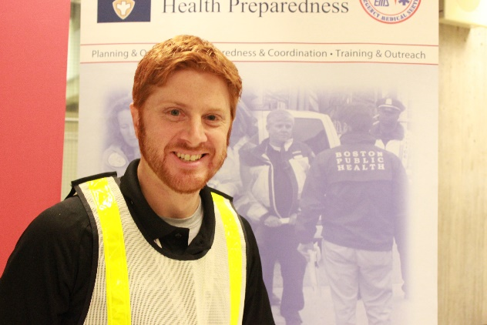Mike Colanti

Mike Colanti, MBA, CEM, CBCP, is the Associate Director for Planning and Operations, and is responsible for overseeing the development of integrated emergency response plans. This includes public health and healthcare partners, community groups, businesses, universities, and volunteers through the Boston Medical Reserve Corps.

He was responsible for leading the collaborative development of a redesigned emergency operations plan (EOP) for the Boston Public Health Commission (BPHC), and led the formulation of the City of Boston’s incident action plan for operational response to H1N1 in 2009. More recently, Mr. Colanti was the lead author for the City of Boston’s health and medical After Action Report for the 2013 Boston Marathon bombings, and coordinated the plan to manage the sheltering and support of 700 individuals following the closure of Boston’s Long Island Bridge in 2014. Previously, Mr. Colanti served in the Boston Mayor’s Office of Emergency Management working with partners throughout the Metro Boston Homeland Security Region, and managed project initiatives across public safety and healthcare disciplines.

Mr. Colanti has a Bachelor of Arts in Political Science from Stonehill College, and an MBA from the Boston University School of Management. He holds professional certifications in project management (PMP), business continuity (CBCP), and emergency management (CEM), and is an active member of the U.S. Department of Health & Human Services Incident Response Coordination Team (IRCT).

Erin Polich

Erin Polich, MPH, is the Senior Program Manager for Emergency Planning at OPHP, and is responsible for overseeing emergency planning within BPHC and partners, and ensuring continuity amongst emergency plans and operational protocols.

Ms. Polich has a Master of Public Health with a concentration in international health from Boston University School of Public Health, and has extensive experience working in emergency public health response overseas in resource limited settings. Prior to joining OPHP, Ms. Polich worked on Ebola response and recovery activities in Sierra Leone, where she coordinated response activities in disease surveillance, infection prevention and control, water and sanitation, and emergency planning. She also coordinated the DFID Ebola Emergency Response Fund, a £12m rapid response fund which awarded more than 60 grants to organizations for Ebola response activities. Prior to this she spent several years working in health coordination at a national level in South Sudan, with a particular focus on maternal and child health and primary healthcare.

Ms. Polich has a Bachelor of Arts in Political Science and History from Fordham University. Other work experience include several years working in domestic violence and women’s empowerment, as well as environmental consulting.

Jared Ulmer

Jared Ulmer, MPH, is the Climate and Health Program Manager at the Vermont Department of Health. Jared collaborates with state, local, and non-governmental partners to increase preparedness for climate-related health impacts in Vermont and promote health improvement through appropriate climate change mitigation strategies. Jared is a member of the American Institute of Certified Planners and previously worked as a consultant helping communities improve public health through transportation systems, community design, and urban forestry.

Catherine Ratté

Catherine Ratté, Principal Planner is the Section Manager of the Land Use/Environment section at the Pioneer Valley Planning Commission. Catherine is an experienced Manager, facilitator and strategic planner, establishing connections and collaborations across disciplines with a focus on sustainability and an emphasis on equity. Catherine’s been with the PVPC for 20 years. Previously she worked for the Wisconsin Department of Transportation, the United States Peace Corps in Cameroon and the Wisconsin Coalition Against Sexual Assault. Catherine has two Master's degrees, Urban and Regional Planning and Social Work, from the University of Wisconsin-Madison and an undergraduate degree from Brown University. Catherine specializes in inter-disciplinary initiatives, at the intersection of community and regional resilience. She grew up in Amherst and is now happily settled in Springfield.

Rui Shi

Rui Shi is a second-year PhD student working with Prof. Benjamin Hobbs at the Department of Environmental Health and Engineering, Johns Hopkins University. His current research interests are focused on decision analysis for adaptation strategies about urban heat, coastal flooding, and inland stormwater, considering robustness and adaptabilities of various alternatives under deep climate uncertainties. He mainly works on a NOAA-funded research project, Mid-Atlantic Regional Integrated Sciences and Assessments (MARISA, <https://www.midatlanticrisa.org/>).

Keith Eggleston

Keith Eggleston is the Regional Climatologist for the Northeast Regional Climate Center located at Cornell University in Ithaca, NY. He has been working for the Climate Center since 1982. His current duties include managing the NRCC’s climate services program and designing and developing climate information products for the Applied Climate Information System (ACIS), such as xmACIS, SC-ACIS, NOWData and AgACIS. He is also heavily involved in the new Northeast DEWS (Drought Early Warning System) and the Network for Environment and Weather Applications (NEWA) projects.

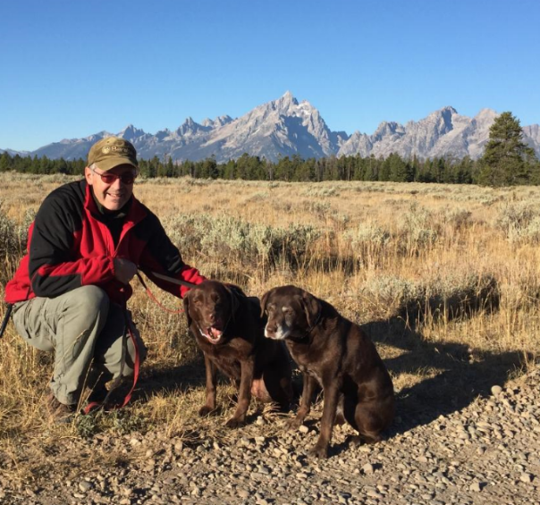Michael McPeck

A graduate of the SUNY College of Environmental Science and Forestry, and Syracuse University with degrees in Forest Engineering and Civil/structural Engineering. Prior employment included work for consulting engineering firm working on bridge and roadway projects, 12 Years with the NYS Department of Environmental Conservation, a few years with UTC/Carrier Corp as Manager of Environmental Programs for North America, and currently is the Manager of Substation Engineering & Design, Civil/Structural Group for National Grid. The National Grid service area covers over 3 million electric customers stretching from the North shore of Massachusetts to the far reaches of western New York. Mike has a deep passion for the outdoors and related activities and his family.